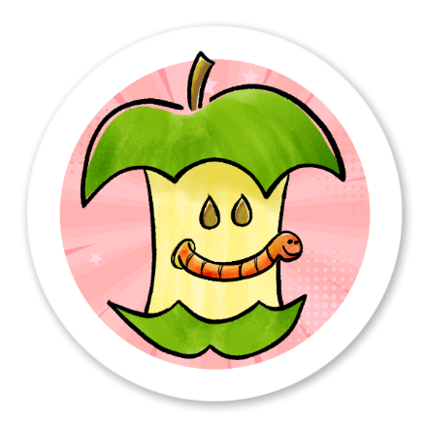
© Sarah Giles for Core Toons
coretoons.substack.com
We don’t want to waste paper, so make a comic with the bottom part of this paper after you cut out your sticker.

